Red Light Therapy For Hair Loss: The Last Treatment You May Ever Need
April 07, 2020

Red Light Therapy for Hair Loss
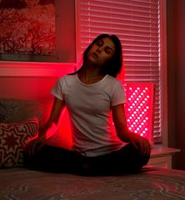
Given the side effects, cost, limited success and ongoing hassles of these common hair restoration treatments, it makes sense to look at an alternative that is painless, non-invasive, has no side effects, and can actually enhance your health in a variety of different ways at the same time. Red light therapy is that option.
And, red light therapy can help improve a variety of other conditions, including joint pain from arthritis, sun damage, and nerve damage, to name a few. In fact, it can even treat one of the root causes of hair loss: thyroid problems.

What Is Red Light Therapy?
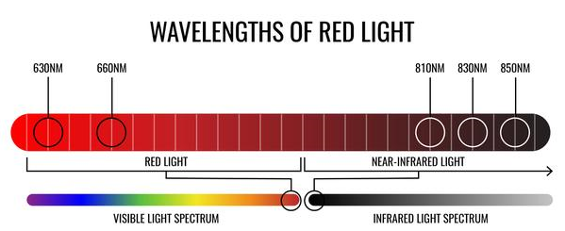
Red light therapy is a type of phototherapy that uses specific wavelengths of light to reduce inflammation, accelerate healing, and promote healthy skin tone. Red light is part of the visible light spectrum (not to be confused with infrared light or ultraviolet light, which are invisible to the human eye), and is bioactive in humans. This simply means that our bodies respond to it beneficially in much the same way that plants respond to sunlight: by creating more energy at the cellular level.
Red light (also called low-level light therapy or LLLT) for hair loss was discovered somewhat by accident in the 1960s, when mice were given chemotherapy. The chemotherapy induced hair loss; but when the mice were irradiated with red light, the fur grew back thicker than before.
Modern red light therapy works in a similar manner, using high-power LEDs to saturate your body with wavelengths of therapeutic light. It typically uses visible light, in a variety of colors, but the red and infrared ranges are best for a wide variety of conditions, including hair loss. While sunlight provides a complete spectrum of wavelengths (including red light) it also contains harmful UVA and UVB wavelengths. Using the red light frequency alone has no side effects such as burning or skin damage.

How Red Light Therapy Restores Hair
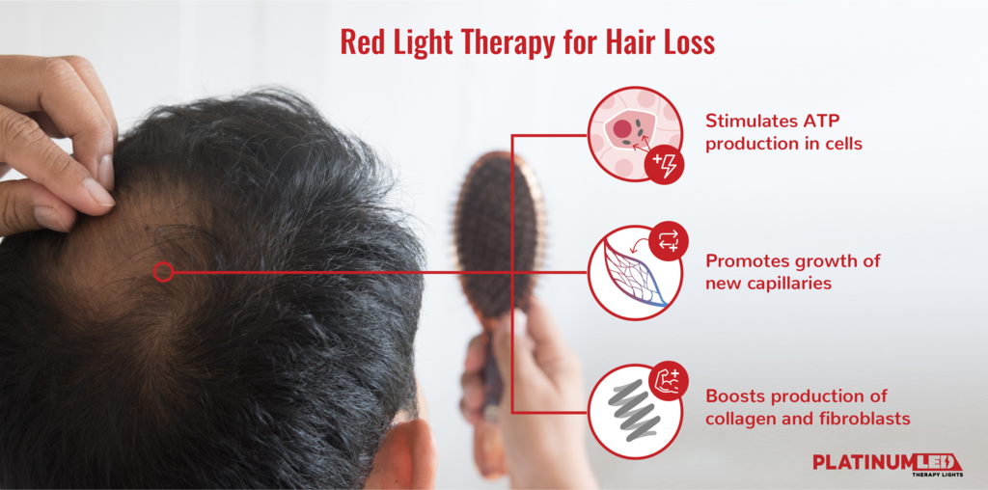
Red light has been found to be especially effective at treating hair loss; specifically, light in the 620nm (nanometer) to 660nm wavelengths work best. It works by increasing blood flow in the scalp; this stimulates the metabolism in hair follicles, resulting in the production of more hair.
During hair loss, you lose hair but not the follicles–the tube-like formations that anchor hair to the skin. At the base of each follicle is the hair bulb (the whole thing looks somewhat like a tall vase). At the bulbous part of the vase are the papilla and the matrix; this is where hair begins to grow. What we see as “hair” is mostly a protein called keratin that makes up the hair shaft. When the cells of the hair follicles and the papilla and matrix are not functioning properly, they cannot support hair growth causing it to slow or cease altogether.
Red light penetrates the skin to the base of the hair follicles, stimulating the cells, papilla and matrix to produce more energy, which results in these cells replicating more successfully. This replication leads to new hair growth from these previously-dormant follicles.
Red light also:
- Stimulates the production of Adenosine Triphosphate (ATP), a coenzyme that is responsible for fueling cellular structures. Increases in ATP cause individual cells within the hair follicle to increase their activity, including the rate at which they replicate. Restoring the energy of the cellular structures of the hair follicles means the papilla creates more keratin, which results in hair growth.
- Increases collagen production. Hair is primarily made up of a protein called keratin. While collagen — another type of protein — isn’t present in hair, it acts as an antioxidant to fight damage caused by free radicals (compounds that develop in the body during stress, environmental pollutants, poor nutrition, etc.). Free radicals damage hair follicles, which contributes to their inability to grow hair. Increased collagen means less oxidative damage, which can lead to increased hair growth.
- Increases the creation of new capillaries, which improves blood flow to the scalp and brings oxygen and nutrients to hair follicles and removes waste that can lead to hair follicle damage. One study linked improved blood flow to growth of thicker, healthier hair. Barbers have long encouraged men to massage their scalps as a way to increase blood flow; but increasing blood flow using red light is generally more effective.
Are There Any Side Effects?
In terms of side effects, there aren’t any that are particularly serious. At worst, overuse of red light therapy can lead to temporary redness, but this is not the same as a “sunburn” that comes from overexposure to ultraviolet light. It might bring a slight bit of discomfort or tightness in the skin, but it fades quickly, making way for all the benefits the treatment provides.
Some hair restoration medication may cause unwanted hair growth, but that’s not the case with red light therapy. Because it stimulates your body’s natural growth processes, hair only grows back where it normally would if your body was operating in top condition.
Cases Where Red Light Does NOT Work
It’s important to note that while red light therapy is effective for many types of hair loss (especially alopecia or temporary hair loss due to hormonal imbalances or illness), it’s not effective 100% of the time. For example, hair loss due to chemotherapy will continue until the treatment is stopped. The same applies to hair loss due to side effects of other medications. Also, any hair follicles that have been destroyed due to injury, surgery, burns, or other permanent injuries will not grow back.
And remember, please see your doctor if you experience sudden or dramatic hair loss, as this can signal a serious underlying condition.

Red and Near-Infrared Light: a Potent Combination
As mentioned earlier, red and near-infrared (NIR) light are the best choice for most LED light therapy applications. However, they work even better when used together since NIR amplifies the effects of red light. Hair growth is stimulated at the scalp level thanks to red light, and NIR adds another dimension to this by helping treat any underlying conditions that could be causing hair loss.
Red light penetrates to the lower layers of skin, which makes it a great tool for treating a variety of skin conditions as well as hair restoration. Near-infrared light is a longer-wavelength light than its red counterpart. At 810-850nm, it is used to facilitate healing deeper in the body, and treat inflammation, improve fat metabolism, heal injuries, accelerate muscle recovery, and even treat cancer.
We mentioned earlier that one of the possible causes of hair loss is thyroid dysfunction. NIR penetrates deep into the body to balance thyroid function. Most people with thyroid imbalances suffer from hypothyroidism, or low thyroid hormone activity that results in low energy throughout the body. The thyroid gland requires energy to perform its functions. By irradiating the thyroid with NIR, more energy becomes available to the cells within the thyroid, thus increasing natural thyroid hormone production. Balanced thyroid functions have a positive ripple effect on the body including reversal of common symptoms of hypothyroid, including weight gain, hair loss, low energy, and low libido.

The Science Behind the Modality
Numerous studies support red light therapy as a safe, painless, and effective treatment for hair loss. Here are just a few:
- A 2014 study on 47 women with androgenetic alopecia found a 37 percent increase in hair growth with no side effects.
- A 2017 study on women found a 51 percent increase in hair count in the group receiving red light therapy.
- A 2017 meta-analysis analyzed 11 studies that included 680 participants. Results reported significant improvements in hair count, hair strength as well as hair density (thicker hair).
- A 2018 meta-analysis reviewed 22 studies that compared red light therapy to other common treatments for hair loss. Researchers concluded that red light therapy had significantly greater effect at treating hair loss with no negative side effects.
- A 2018 study found that red light therapy is an effective and safe treatment for male pattern baldness.
- A 2019 study examined men with male pattern baldness and found that red light enhanced dermal papilla cell function.
Red light therapy is cutting edge, and backed by the latest research from reliable sources. Take a look at the resources above, and contact us if you have any questions.

How Long Does It Actually Take to Regrow Hair?
The best approach is to commit to 1-3 daily sessions of 10-20 minutes each, 3-5 times per week, for a minimum of 3-4 months using a quality LED device with high power output. After this initial treatment period, you can continue with a maintenance program of one or two daily sessions 1-4 times per week indefinitely.
Several months of daily exposure to red light will be necessary before you see significant results. This is due to the natural growth process that begins at the cellular level. Even though hair cells are fast-growing, keep in mind that hair loss typically doesn’t occur overnight, and it will take time for hair to grow to its original natural fullness.

How Far Away Should the Light Be From my Head?
The ideal distance for a red light for practically any therapy is 8 to 14 inches away for maximum results. At this distance, the full power of the light will be absorbed by your skin and hair follicles.
It’s possible to use red light from a bit farther away, especially if only using it for general health and wellness, but for specialized applications like hair loss, it’s essential to use the full power of your device. Especially with hair protecting your scalp, it’s best to keep the light close for the entire duration.
To make this happen, we’d suggest laying down on a flat surface with the light positioned above your head. You can also use a handheld device and hold it in place, but that could get tiring very quickly.
Try to get as much hair out of the way as you can conveniently, but don’t worry if a few strands get between you and the light waves. If you're using a powerful enough device, your scalp should still get enough exposure.
And remember, everyone’s hair grows at a different rate; so don’t compare your results to other people. Be consistent and patient, and you’ll love the results!

Does This Mean You Can Treat Hair Loss at Home?
You can treat hair loss as well as a host of skin conditions using red light therapy in the comfort and privacy of your own home. The key is to use a quality, high-output LED device. Inexpensive helmets, face masks or wands will not deliver the light output necessary to have a truly therapeutic effect.
Red light and red light/NIR combo lights from PlatinumLED are the highest quality panels available today. When you look at the spec sheet, it becomes clear that our technology produces the highest power output and most advanced spectrum of any product on the market, which in turn gives you the best results from at-home light therapy.

Restoring a Healthy Head of Hair, the Red Light Way
As many studies have confirmed, red light therapy stimulates hair growth in both men and women and can, over time, restore a healthy head of hair. Within several weeks you will experience new growth, and new hair will be thicker and more resilient. If you are experiencing hair loss and you’ve been frustrated with the treatments available, try red light, and get your confidence back along with your hair!

